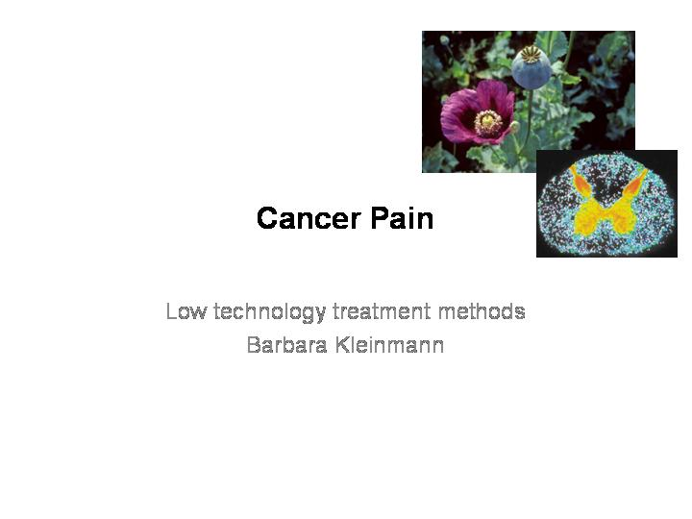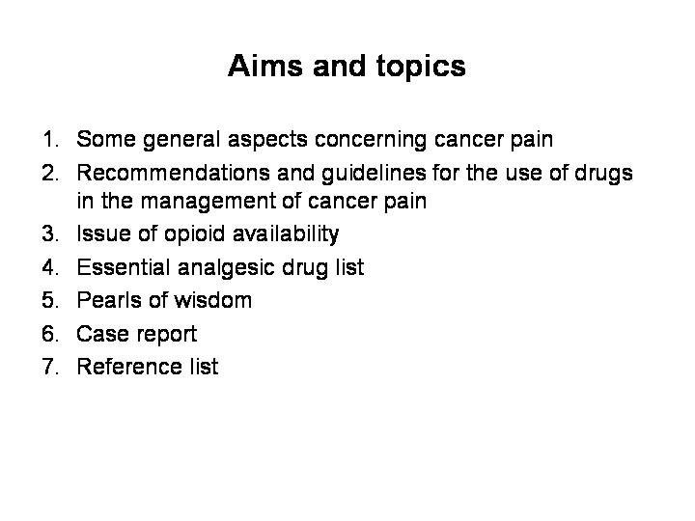

Cancer Pain

Low technology treatment methods
Barbara Kleinmann

Before talking about recommendations and guidelines for the management of cancer pain we should be aware of some general aspects concerning cancer pain.

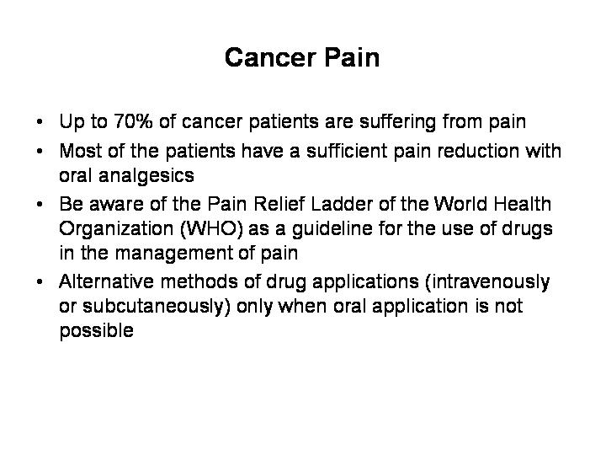

Up to 70% of the cancer patients suffer from severe pain. For this reason the treatment of pain must be of high priority to the physician and the nurses. Most of the patients have a sufficient pain reduction using the easily applied principles of the WHO Pain Relief Ladder. And in most of the cases you will be successful in pain relief with oral analgesics. You should apply alternative methods of drug applications (intravenously, subcutaneously) only in the case when oral application is not possible.

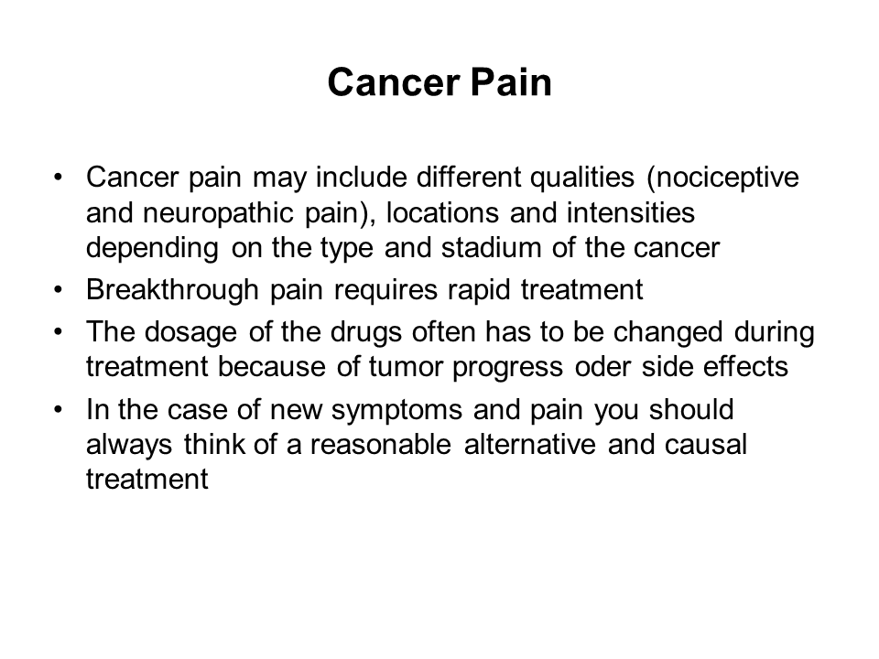

Cancer pain may include different qualities and intensities depending on the type and stadium of the cancer. Therefore it is important to know the etiology of cancer pain: Compression of soft tissues and nerves by the tumor or metastases, pathological fractures or secondary cancer-related pain like decubitus ulcer because of immobilization, herpes zoster because of immunosuppression or neuropathy due to the toxicity of radiotherapy or chemotherapy. The etiology of the pain also defines the quality of the pain: nociceptive pain from a visceral or somatic damage, neuropathic pain from a peripheral or central verve damage or mixed (mixed means a combination of neuropathic and nociceptive pain) pain.
Cancer pain requires appropriate up-titration of around-the-clock pain therapy, whereas breakthrough pain requires rapid treatment when needed. Breakthrough pain is a short-lasting, intense pain with abrupt onset.
During your therapy intensity and quality of pain can change not only because of tumor progress but also because of the cancer therapy and a remission of the disease. The dosage of the used drugs often has to be adapted to tumor stadium and possible side effects.
In the case of new symptoms and pain you should always think of new diagnostics, of a reasonable alternative and causal treatment

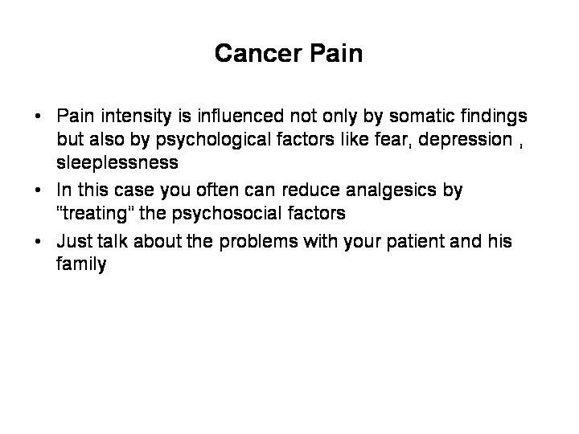

But the pain intensity is influenced not only by somatic findings but also by psychological factors like fear, depression and sleeplessness. Sometimes it could be helpful to ask the patient or the family for these concomitant problems. You often can reduce analgesics by treating the mentioned factors e.g. by calming down the patient or adding an antidepressant. Be always aware of these facts!
Also be aware of possible side effects of cancer pain treatment like constipation, cognitive impairment, dizziness, nausea. Cancer patients may not only suffer from pain but from cancer related symptoms like emesis, vomiting and fatigue. In both cases these symptoms have to be treated.
We will explain our recommendations with the help of a case report:

Case report

- The 59 year old policeman James Window is suffering from a prostate cancer since 2009. After an operative treatment he felt fine for 2 years and continued work. After this period he got pain in his back and the clinical diagnostics found metastases of the spine. He got radiotherapy and with the help of ibuprofen 2 x 600mg pain was reduced for about 3 months.
Then local pain increased despite taking more ibuprofen. Because of this fact James got tramadol, a low-efficacy opioid. He started tramadol with the lowest dosage of 2 x 50mg and with an extended-released formula. But after a short period of time he had to raise the dosage over 2 x 100mg to 2 x 150mg. Then pain decreased to a tolerable level without side effects.
- After a short period of comfortable pain reduction James had to call his general practitioner because of an increasing pain despite of doubling the last dosage of tramadol.
- His general practitioner decided to replace tramadol with the high-efficacy morphine. He started with 2 x 30mg morphine with an extended-release formula and 10mg morphine with an immediate release formula in case of pain attacks. After 3 days he counted the used morphine dosage and adapted it in an extended-release formula. The comfortable dosage of morphine was 2 x 100mg.

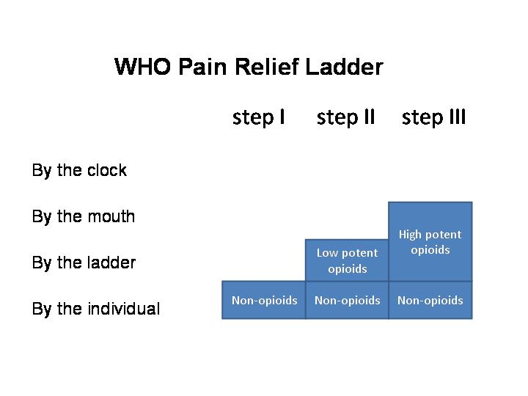

WHO Pain Relief Ladder
For the treatment of cancer pain you should be able to apply the WHO Pain Relief Ladder which is divided in 3 steps:
- Step I involves the administration of non-opioid analgesics
- Step II involves the combination of the non-opioid analgesics with a low-efficacy opioid.
- Step III involves the replacement of the low-efficacy opioid with a high-efficacy opioid
The general recommendations for a therapy with opioids are:
- By the clock, that means periodically
- By the mouth, that means orally
- By the ladder, that means considering the drug steps of the WHO Pain Relief Ladder for pain treatment
- By the individual, that means considering the concomitant diseases, the individual situation and pain condition of the patient

But in case of cancer pain you should immediately switch from step I or step II to step III and treat the patient with a high efficacy opioid.

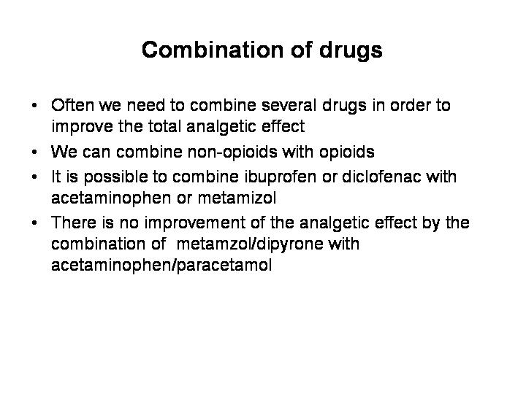

Combination of drugs
As Step II of the WHO Pain Relief Ladder it is recommended to combine the drugs in order to improve the total analgesic effect: You can combine non-opioids with opioids and ibuprofen or diclofenac with acetaminophen or metamizol.
There is no improvement of the analgesic effect by combining metamizol/dipyrone with acetaminophen/paracetamol.

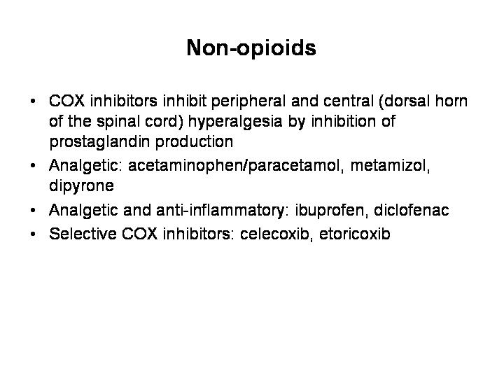

Non-opioids
As important representatives for non-opioids we should first mention the COX inhibitors. They exert analgesia via inhibition of the prostaglandin production peripheral and central in the dorsal horn of the spinal. With the inhibition of the prostaglandin they also reduce the glutamate-mediated transmission and therefore an antihyperalgesic effect. COX inhibitors differ in their pharmacokinetic behavior and some of their unwanted drug effects that are not related to their mode of action.
This group of drugs comprises also nonacidic agents such as acetaminophenon/paracetamol and metamziol/dipyrone. They are analgesic but not anti-inflammatory.

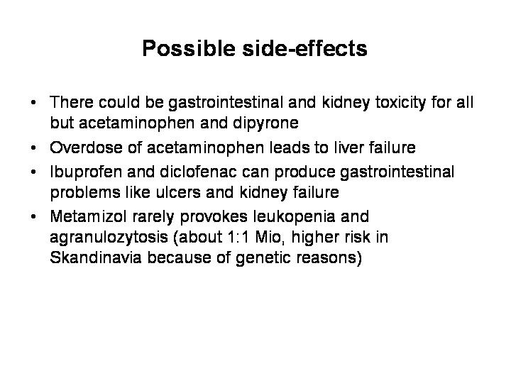

Possible side-effects:
Acidic agents like ibuprofen or diclofenac achieve high concentrations in inflamed tissue. They have an analgesic and anti-inflammatory effect, but gastrointestinal side effects like ulcers and kidney toxicity and interference with blood coagulation are pronounced.
Selective COX-Inhibitors like celecoxib or etoricoxib demonstrate less gastrointestinal toxicity and no interference with blood coagulation.
Metamizol rarely provokes leukopenia and agranulozytosis (about 1:1 Mio., higher risk in Scandinavia because of genetic reasons).

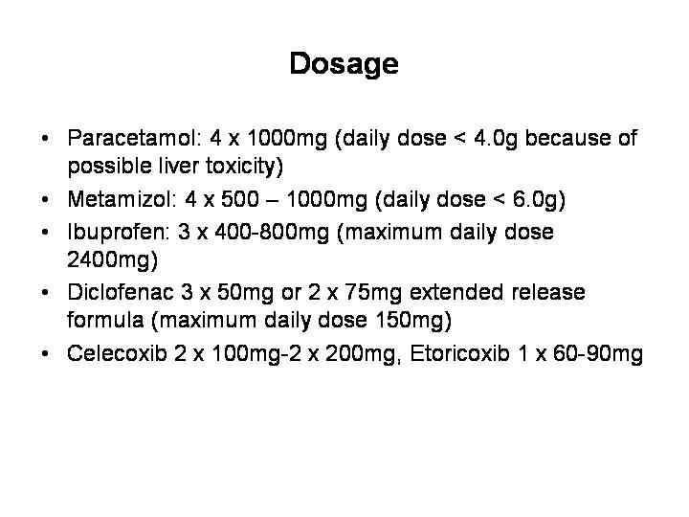

Recommended daily allowance:
Paracetamol: 4 x 1000mg (daily dose < 4.0g because of possible liver toxicity)
Metamizol: 4 x 500 – 1000mg (daily dose < 6.0g)
Ibuprofen: 3 x 400 - 800mg (maximum daily dose 2400mg)
Diclofenac 3 x 50mg or 2 x 75mg extended release formula (maximum daily dose 150mg)
Celecoxib 2 x 100mg - 2 x 200mg, Etoricoxib 1 x 60 - 90mg

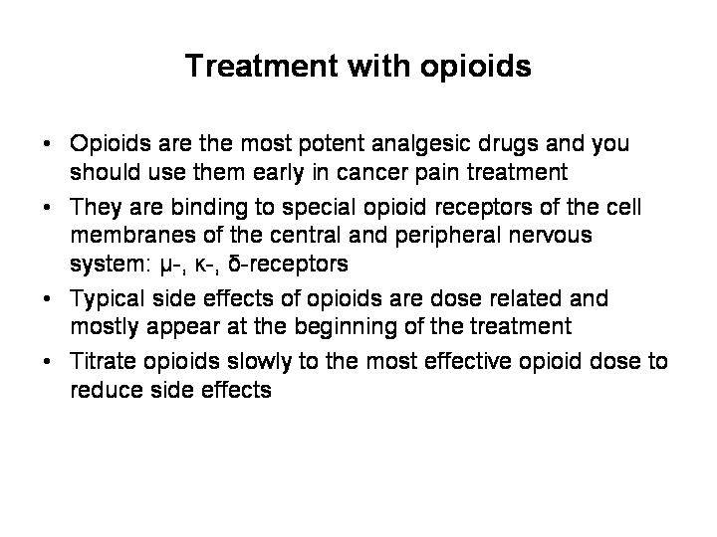

Treatment with opioids and possible side-effects
As Step III of the WHO Pain Relief Ladder we mentioned the high-efficacy opioids. Opioids are the most potent analgesic drugs and you should use them early in cancer pain treatment.
They are binding to special opioid receptors of the cell membranes of the central and peripheral nervous system. Today 3 different opioid receptors are known: µ-, ĸ-, δ-opioid receptors, whereas the µ-receptor is the most important receptor. Nearly all important effects are elicited through its activation. Opioids are distinguished as full agonists and require little receptor occupancy for maximal response, partial opioid agonists e.g. buprenorphine require greater receptor occupancy even for a low response, antagonists like naloxone do not elicit any response.

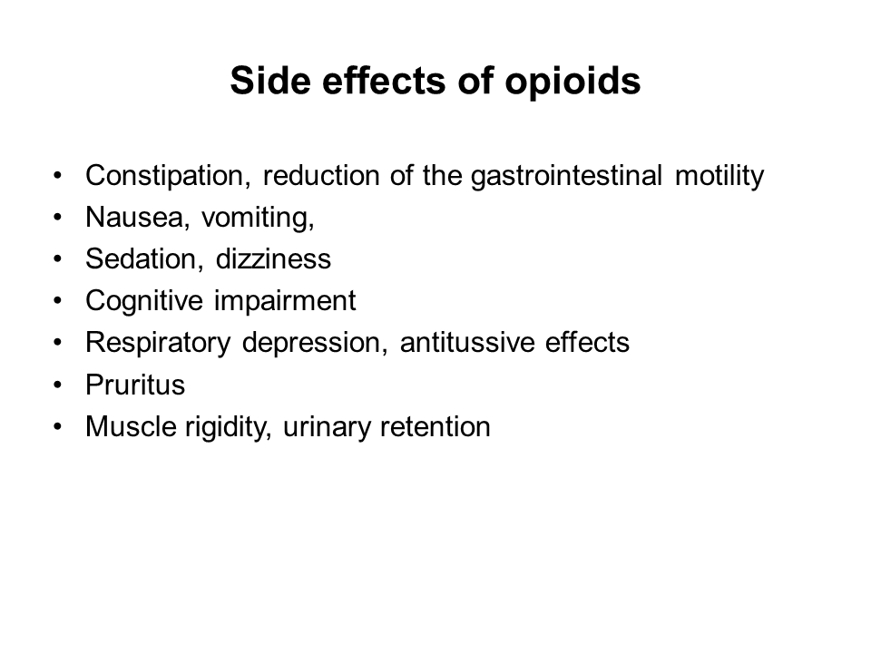

Typical opioid related side effects are dose related and appear at the beginning of an opioid therapy:
- constipation, reduction of the gastrointestinal motility
- nausea, vomiting, sedation, dizziness
- cognitive impairment
- respiratory depression, antitussive effects, pruritus
- muscle rigidity, urinary retention
However after some few days most of these symptoms subside. Patients should be slowly adapted to the most effective opioid dosage to reduce the severity of the side effects. In addition symptomatic treatment of side effects could be necessary.

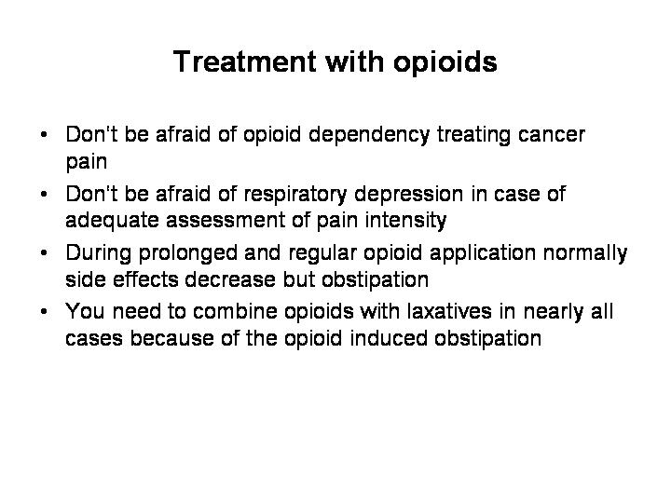
Respiratory depression may be a problem at the beginning, particularly if large doses are given without an adequate assessment to pain intensity. Opioid depression is a result of overdosing instead of titration. During prolonged and regular opioid application normally respiratory depression is no problem and all side effects decrease but obstipation. Therefor you need to combine opioids with laxatives in nearly all cases because of the opioid induced obstipation.
In former times a lot of people took opioids for euphoric effects and were addicted to the drug. Don‘t be afraid of addiction treating cancer pain, as far as you use opioid only for pain therapy!
Up to now there is no organ toxicity reported, even at high doses and with long-term treatment.

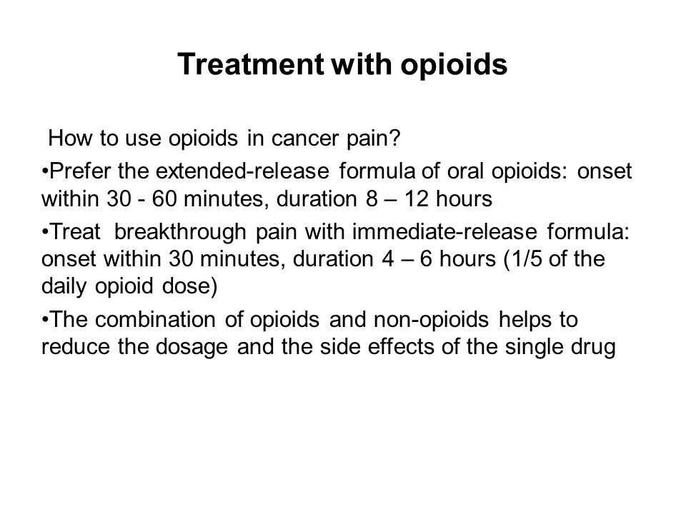

How to use opioids in cancer pain?
Oral opioids are commonly available in 2 galenic preparations, an immediate-release formula and an extended-release formula.
Prefer the extended-release formula of oral opioids with an onset within 30 - 60 minutes and with 8 – 12 hours duration.
Treat breakthrough pain with immediate-release formula: onset within 30 minutes and with a duration of 4 – 6 hours. The dose of the immediate-release formula should be 1/5 of the daily opioid dose.
You need to combine opioids with laxatives in nearly all cases because of opioid induced obstipation.
The most frequently used high potent opioids are:

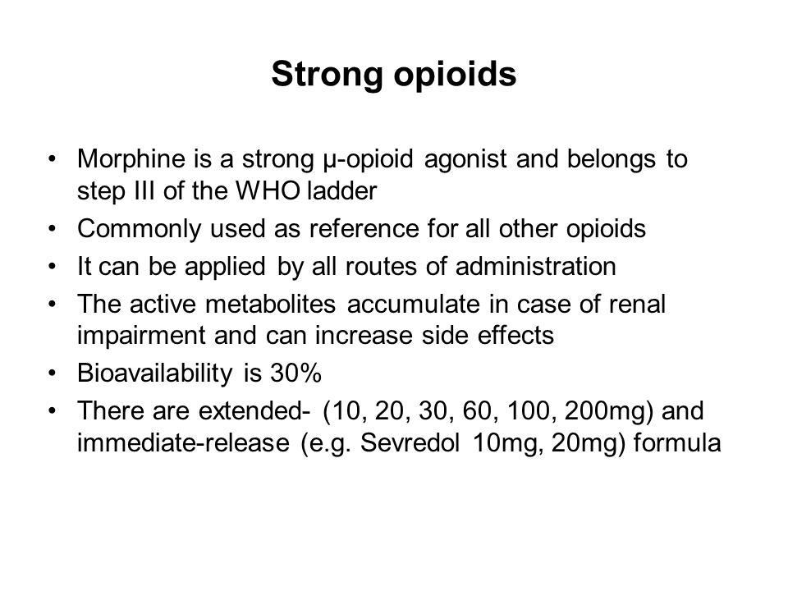

High potent or strong opioids:
- Morphine: is a strong µ-opioid agonist and belongs to step III of the WHO ladder
- Commonly used as reference for all other opioids
- It can be applied by all routes of administration
- The active metabolites accumulate in case of renal impairment and can increase side effects
- Bioavailability is 30%
- There are extended- (10, 20, 30, 60, 100, 200mg) and immediate-released (10mg, 20mg) formula

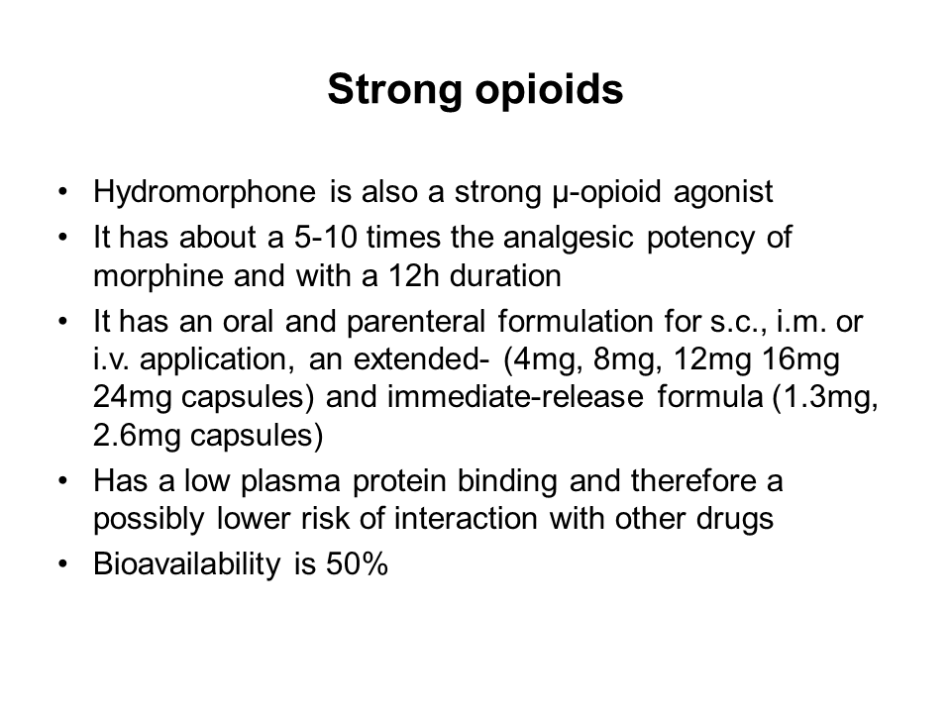

- Hydromorphone: is also a strong µ-opioid agonist
- It has about a 5-10 times the analgesic potency of morphine and with a 12h duration
- It has an oral and parenteral formulation for s.c., i.m. or i.v. application, an extended- (4mg, 8mg, 12mg 16mg 24mg capsules) and immediate-release formula (1.3mg, 2.6mg capsules)
- Has a low plasma protein binding and therefore a possibly lower risk of interaction with other drugs
- Bioavailability is 50%
- In the case of dysphagia you can open the capsules you can mix the pellets with nutrition (not with water) like morphine pellets

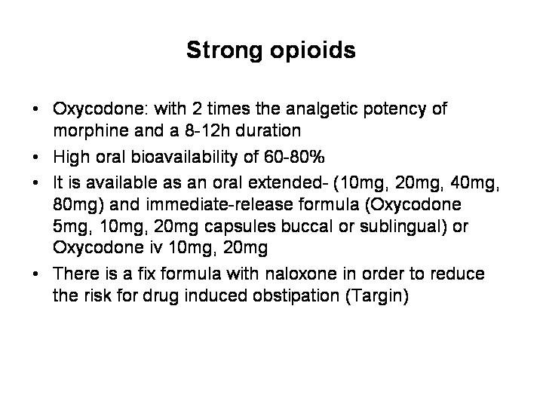

- Oxycodone: with 2 times the analgetic potency of morphine and a 8-12h duration
- High oral bioavailability of 60-80%
- It is available as an oral extended- (10mg, 20mg, 40mg, 80mg) and immediate-released formula (5mg, 10mg, 20mg capsules buccal or sublingual) or for injection 10mg, 20mg
- There is a fix formula with naloxone in order to reduce the risk for drug induced obstipation (Targin)

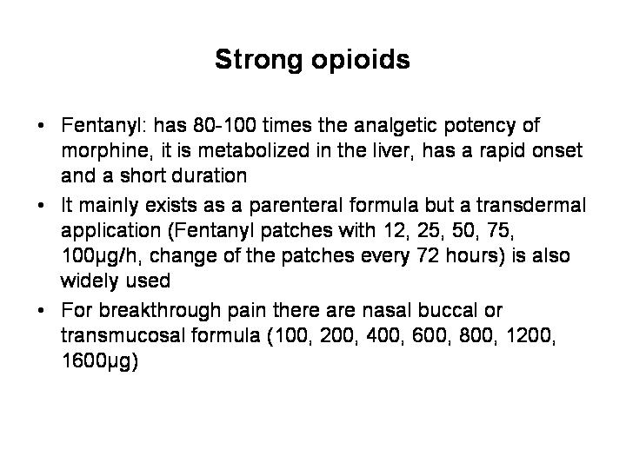

- Fentanyl: has 80-100 times the analgesic potency of morphine, it is metabolized in the liver, has a rapid onset and a short duration

- It mainly exists as a parenteral formula but a transdermal application (Fentanyl patches with 12, 25, 50, 75, 100µg/h, change of the patches every 72 hours) is also widely used. Patches are indicated in the case of dysphagia and stable pain level. For a fast pain escalation patches are not suitable.

- For breakthrough pain there are sublingual or buccal formula (100, 200, 400, 600, 800, 1200, 1600µg)

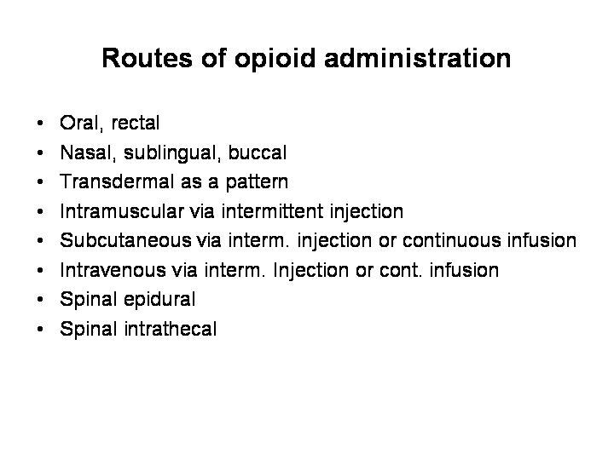

Routes of opioid administration

The preferred route of opioid administration is the oral one. The majority of the opioids are easily absorbed from the gastrointestinal tract but there is a high degree of first-pass metabolism in the liver (40-80%). The duration is depending on the galenic preparations and genetic specifics of the metabolism, e.g. the hepatic enzyme cytochrome P-450.
Different ways of application:

- Oral, preferred route
- Rectal for patients with swallowing
- Nasal, sublingual, buccal for lipophilic opioids like fentanyl
- Transdermal as a patch and for lipophilic opioids
- Intramuscular or subcutaneous via intermittent injection or continuous infusion, the analgesic effect has a delay of 15-20 minutes.
- Intravenous via intermittent injection or continuous infusion, this way is a reliable form with a fast onset of the analgesic effect and by bypass of the hepatic metabolism.
- Spinal epidural or spinal intrathecal, the effects of opioids are terminated by their redistribution into the circulation (neuronal tissue, epidural fat, vessels) and not by their metabolism. The potency of the drugs given within the central nervous system is more than 10 (epidural) -100 (intrathecal) compared to the oral way of application. You should use this way of application only in special cases and when you are accustomed to it.

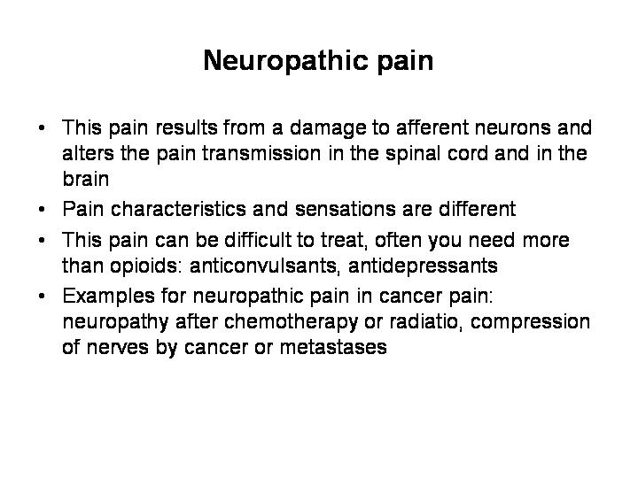

Neuropathic pain

This pain results from a damage of afferent neurons and alters the pain transmission in the spinal cord and in the brain. Neuropathic pain characteristics are different to the pain coming of visceral or somatic damage and it can be more difficult to treat. Often you need different drugs like anticonvulsants and antidepressants, often you have to combine them with opioids.
Examples for neuropathic pain in cancer pain are neuropathy after chemotherapy or radiation and compression of nerves by cancer or metastases.
The patient‘s description of the pain quality is also different: he has sensations like lancinating, burning, electrifying, pricking, tender, numb, throbbing, nagging, hot. Neuropathic pain can impose as a projection or radiation along a course of nerves with segmental or peripheral distribution, as a glove-like distribution or can be attributed to a dermatome. It can be combined with paresis on extremities in the case of a plexopathy.

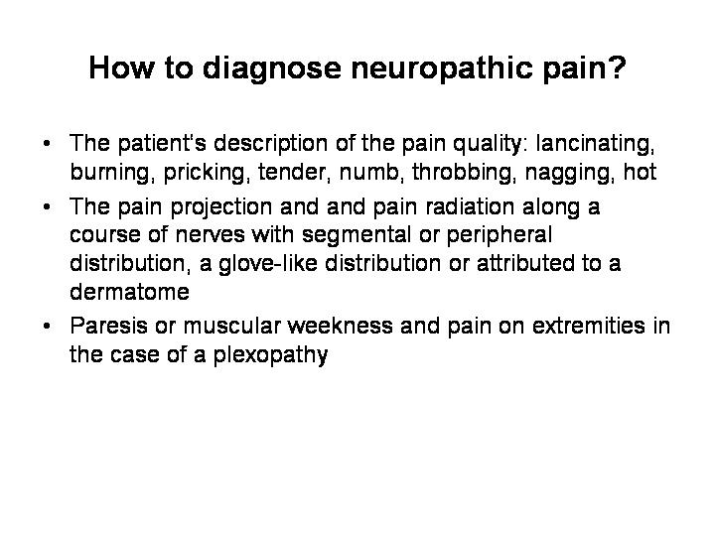
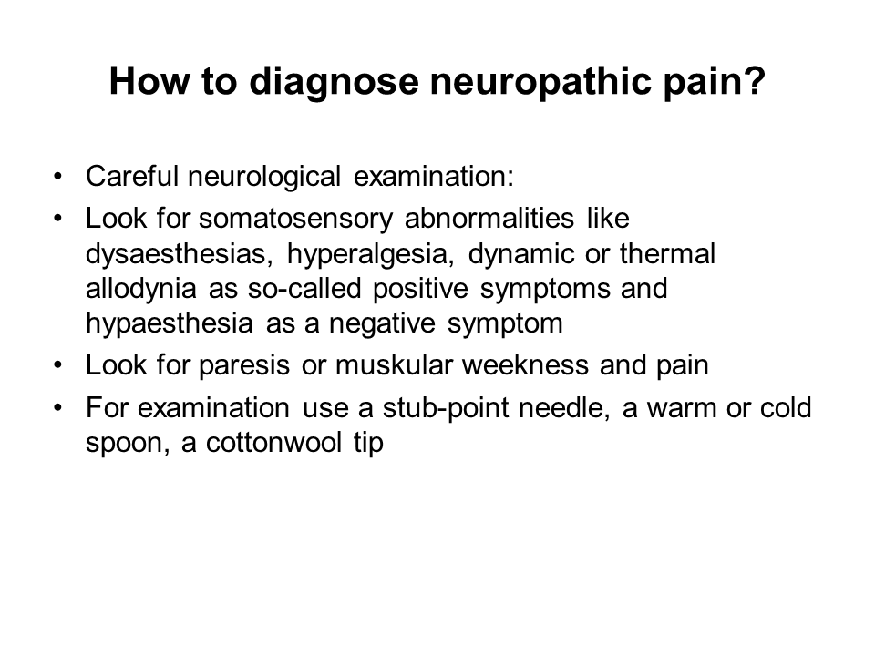

How to diagnose neuropathic pain?

With the help of a careful neurological examination:
Look for somatosensory abnormalities like unusual pain sensations.
Because neuropathic pain is the result of disease or injury of the nervous system, clinical manifestations typically include both negative sensory symptoms and signs like hypaesthesia, paresis and positive sensory symptoms and signs like dysaesthesias, hyperalgesia, dynamic or thermal allodynia. For examination use a stub-point needle, a warm or cold spoon and a cotton wool tip.

.
How to treat neuopathic pain?

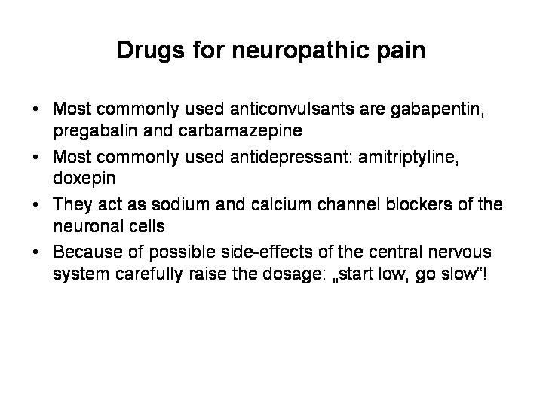

As we already mentioned above we treat this kind of pain with anticonvulsants and antidepressants. In cancer pain you always treat this kind of pain with a combination of opioids and with anticonvulsants and antidepressants, the so called coanalgesics.
Most commonly used anticonvulsants are gabapentin, pregabalin and carbamazepine. These drugs act as sodium and calcium channel blockers of the neuronal cells. Most commonly used antidepressants are tricyclic antidepressants like amitriptyline or doxepin.
Because of possible side-effects of the central nervous system you should carefully increase the dosage of both at the beginning of your therapy: „Start low, go slow“!
Corticosteroids like dexamethasone can reduce pain due to nerve structure compression or edema of metastases

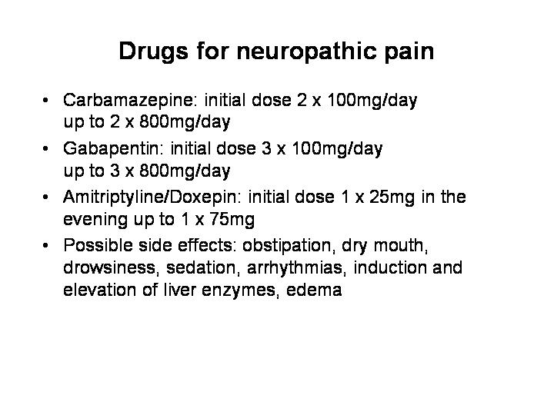

Drugs for neuropathic pain

- Carbamazepine: initial dose 2 x 100mg/day, titrate up to 2 x 800mg/day
- Gabapentin: initial dose 3 x 100mg/day, titrate up to 3 x 800mg/day
- Amitriptyline: initial dose 1 x 25mg in the evening, titrate slowly up to 1 x 75mg
- Doxepin: initial dose 1 x 10mg in the evening, titrate slowly up to 75mg in the evening
Possible side effects: obstipation, dry mouth, drowsiness, sedation, arrhythmias, induction and elevation of liver enzymes, edema

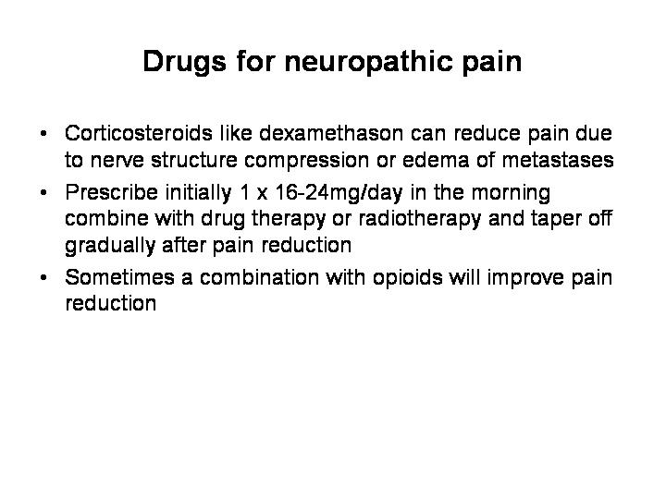

- In the case of nerve structure compression or edema of metastases prescribe initially dexamethasone 1 x 16-24mg/day in the morning, combine with drug therapy or radiotherapy and taper off gradually after pain reduction.

Case report
- Pain was sufficiently treated but James got another problem:
He suffered from nausea and constipation. With the help of lactulose 3 x 10mg/day and metoclopramide 4 x 10mg/day this problem could be solved. In the next 6 months the situation was stable.
- After this time pain increased again because of his progressive disease. He got a new burning pain without reduction of the pain intensity by taking more morphine. Also he got a sensitive deficit perineal because of an infiltration of the plexus pudendus. Under the treatment with dexamethasone 12 mg and gabapentin 3 x 300mg/day (going up in 100mg steps) the pain decreased again.
- Because of his cancer disease James felt tired and lethargic. He had lost a lot of power and energy and even if there are some days with good quality of life despite his disease there are also days with depression. During these days with depression pain matters him more than during the days before. Because of James bad mood his family and friends pay more attention to James. Until his death, there was no need to increase the dose of drugs he was given.

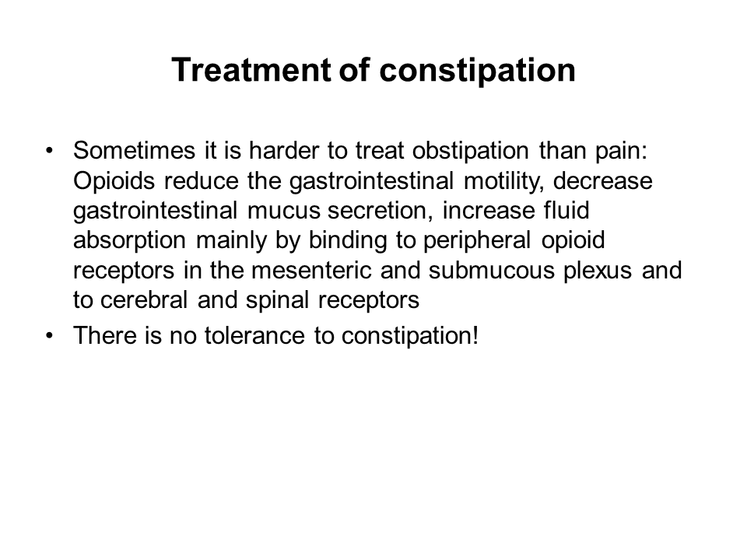

Treatment of constipation

Sometimes it is harder to treat constipation than pain:
Opioids reduce the gastrointestinal motility decrease the gastrointestinal mucus secretion mainly by binding to peripheral opioid receptors in the mesenteric and submucous plexus and to cerebral and spinal receptors. So you have to treat obstipation at the same time you start with an opioid treatment.
And be aware of the fact, that there is no tolerance to obstipation!

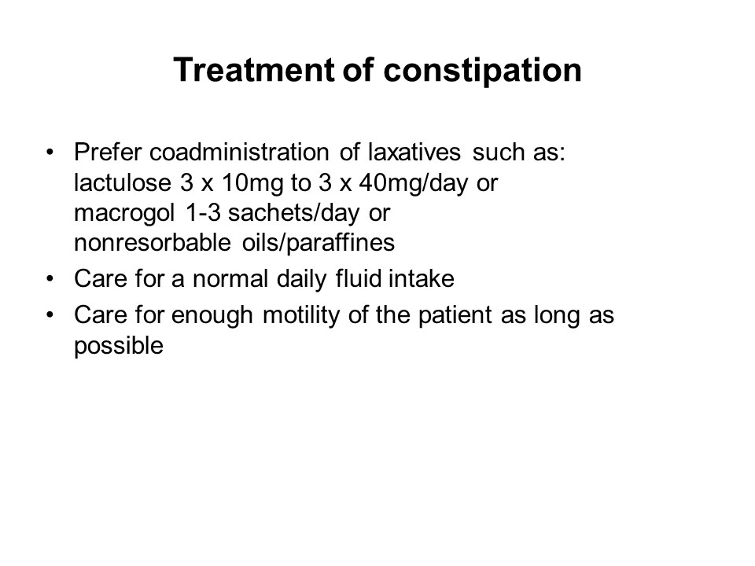

Prefer coadministration of laxatives such as lactulose 3 x 10mg to 3 x 40mg/day or macrogol 1-3 sachets/day or nonresorbable oils/paraffines orally.
To prevent constipation it is also important to care for a normal daily fluid intake as well as to take care for enough motility of the patient as long as possible.

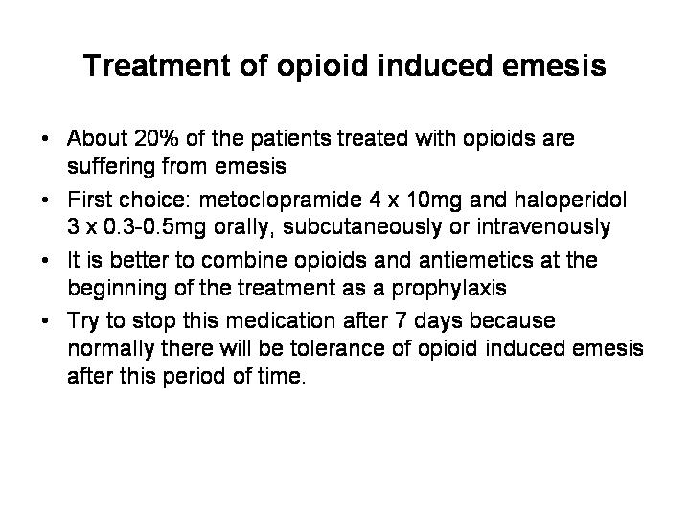

Treatment of opioid induced emesis

About 20% of the patients treated with opioids are suffering from emesis.
For the treatment of emesis metoclopramide 4 x 10mg/day and haloperidol (Haldol) 3 x 0.3-0.5mg/day orally, subcutaneously or intravenously alone or in combination are recommended as first choice.
Like the treatment of opioid induces obstipation it is better to combine opioids and antiemetics at the beginning of the treatment as a prophylaxis.
Try to stop the antiemetics after 7 days because normally there will be tolerance of opioid induced emesis after this period of time.

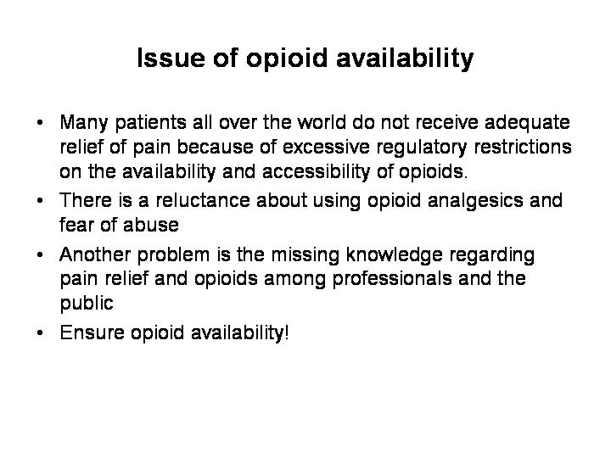

Issue of opioid availability

Many patients all over the world do not receive adequate relief of pain because of excessive regulatory restrictions on the availability and accessibility of opioids. This is a major public health problem.
Although international and national expert groups have determined that opioid analgesics are essential for the relief of pain it is often inadequately treated because of reluctance about using opioid analgesics and fear of abuse.
Another major barrier to access opioids is the missing knowledge regarding pain relief and opioids among professionals and the public. Therefore it is necessary to promote the rational use of medical opioids and the adequate treatment of patients with cancer e.g. with the help of improved education of professionals.

Ensure opioid availability

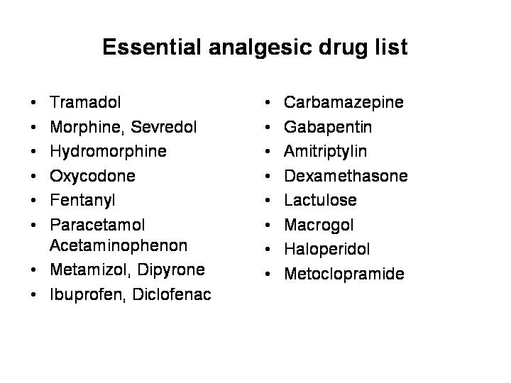

Essential analgesic drug list
In order to enable a sufficient pain therapy for cancer patients and regarding the commonly used drugs we suppose the following drug list for essential:

Tramadol
Morphine
Sevredol as immediate-released morphine sulphate
Hydromorphine
Hydromorphone as immediate-released formula
Oxycodon and Oxycodone/Naloxon (Targin)
Oxycodone as immediate-released formula
Fentanyl
Paracetamol/Acetaminophenon
Metamizol/Dipyrone
Ibuprofen, Diclofenac
Carbamazepine
Gabapentin
Amitriptylin
Dexamethasone
Lactulose
Macrogol
Haloperidol
Metoclopramide

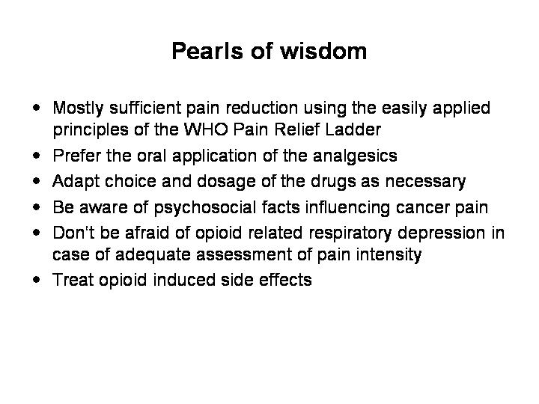

Pearls of wisdom

- Most of the patients have a sufficient pain reduction using the easily applied principles of the WHO Pain Relief Ladder
- You should apply alternative methods of drug applications (intravenously, subcutaneously) only in the case when oral application is not possible.
- Be aware of the fact, that cancer pain can change during cancer treatment and that you may have to adapt your therapy
- Be aware of psychosocial facts influencing cancer pain
- Adjust opioid dosage on patients pain and conditions
- Don‘t be afraid of opioid related respiratory depression in case of adequate assessment of pain intensity
- Treat opioid induced side effects like obstipation and emesis simultaneously and as a prophylaxis
- There may be different pain types and origin. For neuropathic or mixed pain use antidepressants or anticonvulsants

Reference list

- Core Curriculum for Professional Education in Pain
J. Edmond Charlton
- Guide to Pain Management in Low-Resource-Settings
IASP
- The Pain Management Core Curriculum for European Medical Schools, Version October 2009
DGSS, EFIC
- Medikamentöse Schmerztherapie bei Tumorpatienten, ein Leitfaden, 10. überarbeitete Auflage
E. Klaschnik

